***WEEK 7.10***

***Currency Converter***

***App.js***

import React, { useState } from 'react';

// --- CurrencyConvertor Component ---

// This component handles the conversion from INR to a target currency.

const CurrencyConvertor = () => {

  // State to hold the input value (Amount) and the result

  const [amount, setAmount] = useState('');

  const [result, setResult] = useState('');

  // Handles the conversion when the form is submitted

  const handleSubmit = (event) => {

    // Prevents the form from submitting and reloading the page

    event.preventDefault();

    // Simple conversion for demonstration (e.g., INR to EUR)

    const INR_TO_EUR_RATE = 0.011;

    const convertedValue = parseFloat(amount) * INR_TO_EUR_RATE;

    // We can display the result in an alert or update the state

    if (!isNaN(convertedValue)) {

        setResult(`Converted Amount: €${convertedValue.toFixed(2)}`);

        alert(`Converted Amount: €${convertedValue.toFixed(2)}`);

    } else {

        alert("Please enter a valid amount.");

    }

  };

  return (

    // The form for currency conversion

    <form onSubmit={handleSubmit} style={{ marginTop: '30px' }}>

      <h2 style={{ color: 'green' }}>Currency Convertor!!!</h2>

      <div>

        <label htmlFor="amount" style={{ marginRight: '10px' }}>Amount:</label>

        <input

          id="amount"

          type="text"

          value={amount}

          onChange={(e) => setAmount(e.target.value)}

        />

      </div>

      <div style={{ marginTop: '10px', marginBottom: '10px' }}>

        <label htmlFor="currency" style={{ marginRight: '10px' }}>Currency:</label>

        <input

          id="currency"

          type="text"

          // This field is decorative to match the image

          placeholder="EUR"

        />

      </div>

      <button type="submit">Submit</button>

    </form>

  );

};

// --- Main App Component ---

// This is the root component that contains all the event examples.

function App() {

  // State for the counter

  const [count, setCount] = useState(5); // Initial count set to 5 as in the image

  // 1. Function to increment the counter

  const incrementCounter = () => {

    setCount(prevCount => prevCount + 1);

  };

  // 2. Function to decrement the counter

  const handleDecrement = () => {

    setCount(prevCount => prevCount - 1);

  };

  // 3. Handler that takes an argument

  const sayMessage = (message) => {

    alert(message);

  };

  // 4. Handler for the synthetic event example

  const handlePress = (event) => {

    // React's SyntheticEvent provides a consistent API across browsers.

    console.log(event); // You can inspect the SyntheticEvent object

    alert("I was clicked");

  };

  // 5. Handler for the increment button that also shows a message

  const handleIncrementAndSayHello = () => {

      incrementCounter();

      // This fulfills the original requirement of the increment button invoking multiple methods

      console.log("Hello! Counter was incremented.");

  }

  return (

    <div style={{ padding: '20px', fontFamily: 'sans-serif' }}>

      {/* Display the current count */}

      <p style={{ fontSize: '20px', fontWeight: 'bold' }}>{count}</p>

      {/* Buttons for various event demonstrations */}

      <div>

        <button onClick={handleIncrementAndSayHello}>Increment</button>

      </div>

      <div style={{ marginTop: '5px' }}>

        <button onClick={handleDecrement}>Decrement</button>

      </div>

      <div style={{ marginTop: '5px' }}>

        <button onClick={() => sayMessage('Welcome')}>

          Say Welcome

        </button>

      </div>

      <div style={{ marginTop: '5px' }}>

        <button onClick={handlePress}>

          Click on me

        </button>

      </div>

      {/* Currency Converter Component */}

      <CurrencyConvertor />

    </div>

  );

}

export default App;

***OUTPUT***

***Increment***

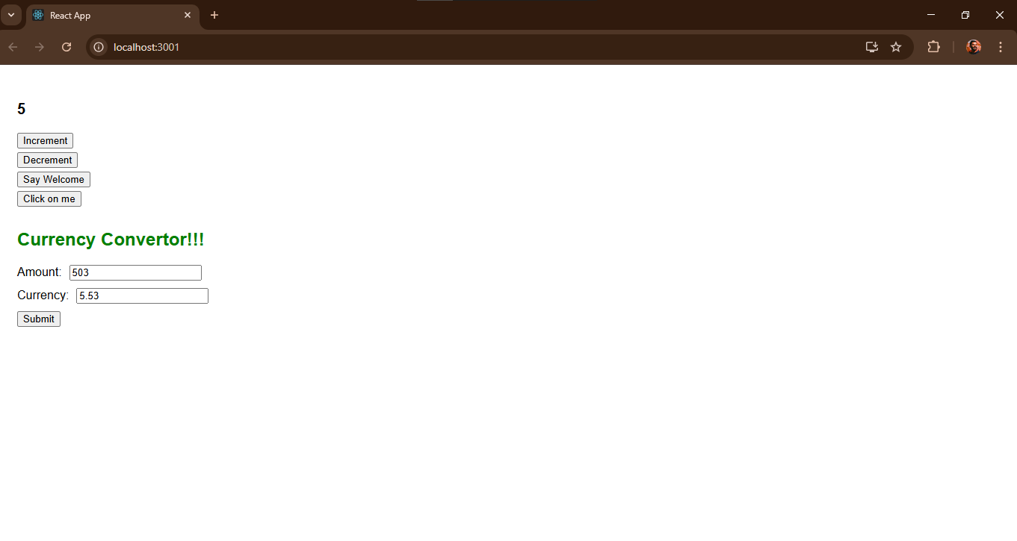

***Decrement***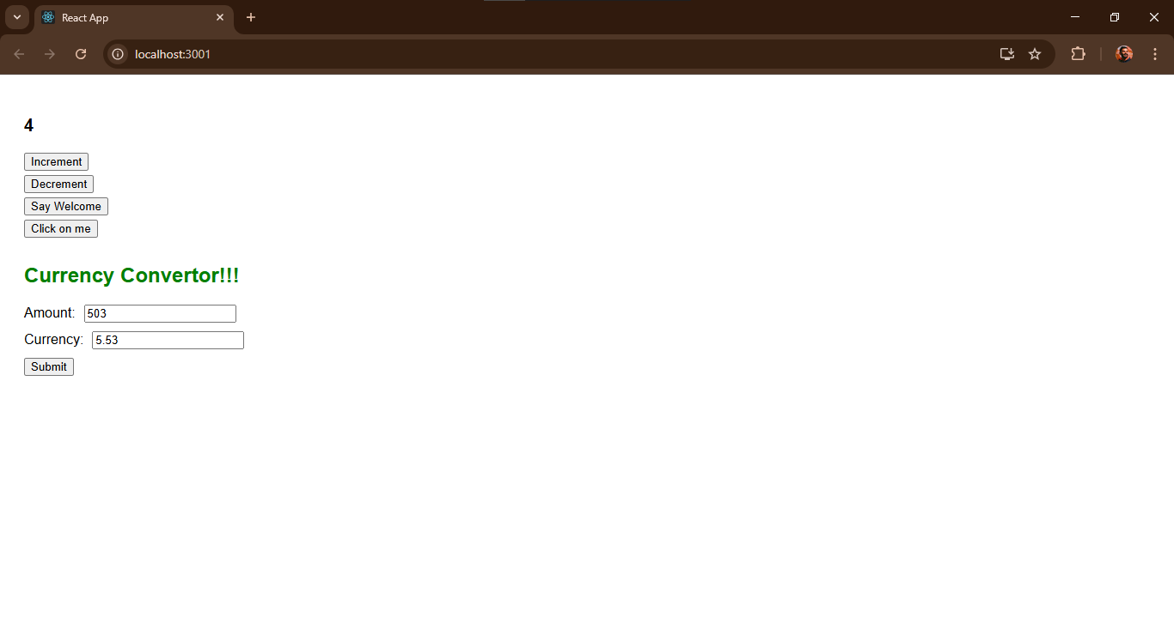

**Currency converter**

